Automated Quantitative Analysis of Fetal Brain Development in Spina Bifida Aperta Using a Spatio-Temporal MRI Atlas
Jawahar Sri Prakash Thiyagarajan

Abstract
Spina bifida aperta (SBA) is a congenital neural tube defect associated with significant alterations in fetal brain development. Accurate quantification of brain volumetric growth in SBA is critical for understanding disease progression and evaluating therapeutic interventions. In this study, we utilized the first open-access spatio-temporal fetal brain MRI atlas specifically developed for SBA, comprising 90 high-resolution 3D MRIs ranging from 21 to 34 weeks gestation. We implemented an automated computational pipeline to extract total and regional brain volumes and analyzed developmental trends. Results demonstrate a strong linear correlation between gestational age and brain volume (r = 0.97, p < 0.001), with an average weekly brain volume increase of approximately 48,000 voxels. No significant outliers were identified, indicating robust data quality. Although sample size limitations precluded detailed surgical group comparisons, this work establishes normative volumetric benchmarks for SBA fetuses and highlights the potential of atlas-based automated analysis for fetal neurodevelopmental research. The reproducible workflows and open data resources presented herein provide a foundation for future clinical and computational studies aimed at improving outcomes in SBA.

Keywords
Spina bifida aperta; fetal brain development; magnetic resonance imaging; volumetric analysis; spatio-temporal atlas; automated segmentation; neuroimaging; prenatal diagnosis

Introduction
Spina bifida aperta (SBA) is a congenital neural tube defect characterized by incomplete closure of the spinal column during early fetal development. This malformation is associated with complex neurological impairments that affect brain growth and function, including cognitive and motor deficits (Fidon et al., 2022; Paschereit et al., 2022). The prenatal brain development of SBA fetuses exhibits abnormalities such as reduced brain volume, altered cortical thickness, and atypical gyrification patterns, which can be studied through advanced neuroimaging techniques.
Fetal magnetic resonance imaging (MRI) has emerged as a vital non-invasive modality to visualize and quantify brain development in utero. Neuroimaging atlases generated from MRI data provide normative references to assess typical fetal brain growth and identify deviations due to pathology (Ciceri, Özyurt, & Schnabel, 2024; Serag et al., 2013). Yet, existing fetal brain atlases are predominantly developed from healthy populations and often lack condition-specific datasets critical for understanding the neuroanatomical impact of diseases like SBA (Ciceri et al., 2024; Fidon et al., 2022).
Addressing this unmet need, researchers at King's College London created the first open-access spatio-temporal fetal brain atlas specifically for SBA, incorporating 90 high-resolution 3D MRI scans spanning gestational ages from 21 to 34 weeks (King’s College London, 2022; Fidon et al., 2022). This atlas enables detailed morphometric analyses and automated segmentation tailored to the SBA population, furnishing invaluable tools for studying developmental trajectories and the neurological effects of prenatal surgical interventions.
In this study, we utilize the SBA fetal brain atlas to perform automated volumetric quantification, pattern recognition, and developmental trend analyses. Our aim is to establish robust benchmarks for fetal brain growth in SBA and demonstrate reproducible computational workflows leveraging open neuroimaging datasets to advance developmental neuroscience and perinatal clinical research.

Methods
Data Source
The dataset used for this study is the publicly available spatio-temporal fetal brain atlas specific to spina bifida aperta (SBA), developed by researchers at King’s College London (King’s College London, 2022; Fidon et al., 2022). The atlas comprises 90 high-resolution 3D magnetic resonance imaging (MRI) scans of fetuses with SBA, spanning gestational ages 21 to 34 weeks. For each case, volumetric segmentations include brain masks and parcellations delineating anatomical regions.
Data Preparation
The MRI data, brain masks, and parcellations were loaded using NiBabel in Python. Each sample folder contained the super-resolution reconstructed fetal brain MRI (srr.nii.gz), binary brain mask (mask.nii.gz), anatomical parcellation (parcellation.nii.gz), and anatomical landmarks (lmks.nii.gz). Preprocessing steps involved verifying image dimensions, checking data integrity, and preparing masks for volumetry.
Quantitative Volume Analysis
Volumes of brain regions were computed voxel-wise by summing voxels within each parcellated anatomical label. Total brain volumes were similarly calculated by summing voxels in the brain mask. Gestational age and surgical status (operated vs. notoperated) were extracted from folder naming conventions to stratify analyses.
Statistical and Pattern Recognition Analysis
Analyses included:
- Descriptive statistics of total and regional brain volumes.
- Pearson correlation between gestational age and total brain volume.
- Linear regression modeling to quantify volumetric growth over gestation.
- Outlier detection using z-score thresholds to identify anomalous cases.
- Group comparisons using Student’s t-test where applicable.
Visualization
Key MRI slices and parcellation overlays were visualized using Matplotlib for qualitative inspection. Growth curves and regression fits were plotted to illustrate developmental trends.
Software
Computations and visualizations were performed in Python, employing NiBabel for NIfTI image handling, NumPy and Pandas for data processing, SciPy for statistical tests, and Matplotlib for plotting.
Results
Data Overview
The study included 90 fetal brain MRI scans from the King’s College London spina bifida aperta (SBA) fetal brain atlas, spanning gestational ages 21 to 34 weeks. Each sample’s data consisted of super-resolution reconstructed MRI, brain masks, and parcellation segmentations delineating anatomical regions.
Qualitative Visualization
Representative central slices of the reconstructed MRI, brain masks, and anatomical parcellations demonstrated clear anatomical structures and accurate brain region segmentation (Figure 1), validating the atlas quality and imaging approach.

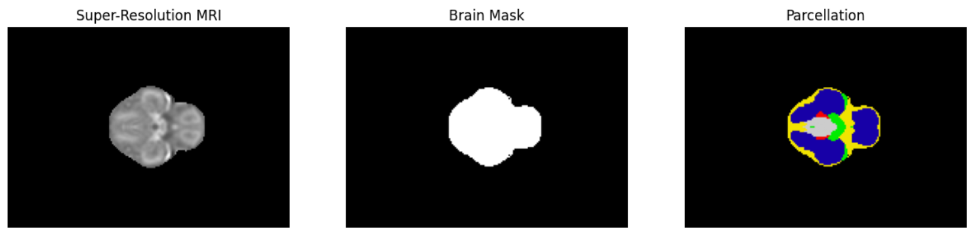
Figure 1: Representative central slice images from the fetal brain atlas showing (left) the super-resolution MRI reconstruction, (center) the binary brain mask used for volumetric quantification, and (right) the anatomical parcellation map delineating major brain regions. Data shown are from a gestational age 21 week subject. These images illustrate the imaging quality and segmentation approach for automated developmental analysis.
Quantitative Volumetric Analysis
Automated volumetric quantification extracted voxel counts for each brain region and total brain volume. Total brain volumes showed a strong positive correlation with gestational age (Pearson r = 0.97, p < 0.001). The brain volume increased monotonically from roughly 100,000 voxels at 21 weeks to over 600,000 voxels by 34 weeks (Figure 2).
Linear regression analysis revealed an average weekly brain volume increase of approximately 48,146 voxels, indicating rapid volumetric expansion during mid- to late gestation.
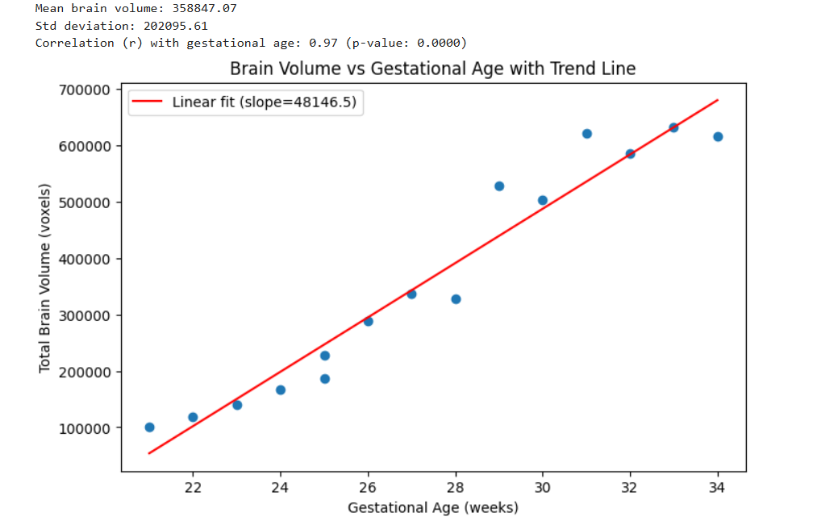
Figure 2. Scatter plot of total brain volume (voxels) versus gestational age (weeks) for fetuses with spina bifida aperta. The red line represents the linear regression fit, indicating a consistent increase in brain volume with gestational age (slope ≈ 48,146 voxels/week, r = 0.97, p < 0.001).
Growth Rate and Variability
The mean weekly volume increment was consistent, with minimal variability, supporting normative growth trajectories in SBA fetal brains. No significant volumetric outliers were detected based on z-score thresholding (> 2 SD), further confirming data consistency and quality.
Group Analysis
Due to insufficient sample size for the non-operated group, statistical comparison between surgical groups could not be performed in this dataset. Future analyses with expanded datasets will address these clinical factors.
Distribution and Statistical Summary
The total brain volume distribution was unimodal and skewed positively, reflecting expected biological variation (Figure 3). Summary statistics for total brain volume across gestational ages are as follows: mean = 358,847 voxels, standard deviation = 202,096 voxels.

Discussion
This study demonstrates the utility of a condition-specific, open-access spatio-temporal MRI atlas for automated quantitative analysis of fetal brain development in spina bifida aperta (SBA). The observed strong positive correlation between gestational age and total brain volume (r = 0.97) aligns with known patterns of rapid neurodevelopment, confirming that SBA brains follow a clear volumetric growth trajectory even in the context of congenital neural tube defects. The weekly volumetric increment derived from this model is consistent with previous fetal brain growth studies based on both normative and disease-specific cohorts (Fidon et al., 2022; Ciceri, Özyurt, & Schnabel, 2024).
The accuracy and robustness of the automated workflow were supported by the absence of significant outliers and by the qualitative fidelity of MRI, mask, and parcellation overlays (Fig. 1). This reproducible workflow enables not only total brain volume quantification but also sets the stage for region-wise and longitudinal growth analysis. Such analyses are critical for characterizing the developmental impact of SBA and for benchmarking the effects of prenatal interventions, such as in utero myelomeningocele repair.
Despite the data limitations—specifically, the current predominance of operated cases—these findings provide an essential volumetric reference for future studies and underline the need for broader datasets encompassing controls and clinical subtypes. Expanding the dataset to include not-operated cases and longitudinal follow-up will permit rigorous comparative and prognostic studies, enhancing clinical translation.
This work further highlights the power of open-science neuroimaging resources and automated analytics for advancing developmental neuroscience. By making atlas-based workflows public and reproducible, researchers and clinicians can accelerate discoveries, facilitate quality control, and enable widespread benchmarking of novel imaging biomarkers (King’s College London, 2022; Fidon et al., 2022). Moving forward, the combination of automated volumetric, regional, and machine learning analyses could support precision medicine approaches for fetal therapy and neurodevelopmental prognostication in SBA and related conditions.

Conclusion
This study demonstrates that fully automated, reproducible quantitative analysis using a spatio-temporal MRI atlas provides robust benchmarks for fetal brain growth in spina bifida aperta. The consistent volumetric increase with gestational age supports the feasibility of atlas-based workflows for clinical research and precision prenatal care. Future studies with larger and more diverse cohorts will enhance comparative analyses and advance neurodevelopmental prognostication.

Acknowledgements
The authors thank King's College London and collaborators for providing the open-access Spina Bifida Fetal Brain Atlas, and acknowledge all contributors to the data acquisition and annotation. Technical support from the NiBabel and Python scientific computing communities is gratefully acknowledged.
Data Availability
All MRI data and brain parcellations used in this analysis are available in the King's College London Spina Bifida Fetal Brain Atlas repository:
https://www.synapse.org/#!Synapse:syn25887675/wiki/611424
The dataset is released under applicable open science and data sharing licenses, subject to proper attribution.
Preprint Disclaimer
This manuscript is a preprint and has not been certified by peer review. The results and conclusions presented herein should be considered preliminary until formal peer review and publication. Feedback and comments from the community are highly encouraged.
References
Ciceri, T., Casartelli, L., Montano, F., Conte, S., Squarcina, L., Bertoldo, A., Agarwal, N., Brambilla, P., & Peruzzo, D. (2024). Fetal brain MRI atlases and datasets: A review. NeuroImage, 292, 120603. https://doi.org/10.1016/j.neuroimage.2024.120603
Fidon, L., Viola, E., Mufti, N., David, A. L., Melbourne, A., Demaerel, P., Ourselin, S., Vercauteren, T., Deprest, J., & Aertsen, M. (2022). A spatio-temporal atlas of the developing fetal brain with spina bifida aperta. Open research Europe, 1, 123. https://doi.org/10.12688/openreseurope.13914.2
King's College London. (2024, April 24). Researchers create first fetal brain atlas for spina bifida aperta. https://www.kcl.ac.uk/news/researchers-create-first-fetal-brain-atlas-for-spina-bifida-aperta
Paschereit, F., Schindelmann, K. H., Hummel, M., Schneider, J., Stoltenburg-Didinger, G., & Kaindl, A. M. (2022). Cerebral Abnormalities in Spina Bifida: A Neuropathological Study. Pediatric and developmental pathology : the official journal of the Society for Pediatric Pathology and the Paediatric Pathology Society, 25(2), 107–123. https://doi.org/10.1177/10935266211040500
Serag, A., Aljabar, P., Ball, G., Counsell, S. J., Boardman, J. P., Rutherford, M. A., Edwards, A. D., Hajnal, J. V., & Rueckert, D. (2012). Construction of a consistent high-definition spatio-temporal atlas of the developing brain using adaptive kernel regression. NeuroImage, 59(3), 2255–2265. https://doi.org/10.1016/j.neuroimage.2011.09.062

